Addressing Student Trauma by Questioning Labels
Presented by Darrell K. Bingham and Jeffery D. Hendricks
- Fondness – What brought me to the relationship, career, the situation…?
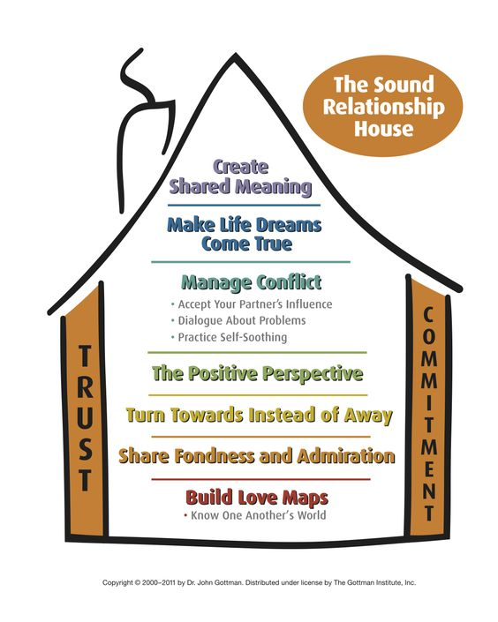
John Gottman PhD.
Site: https://www.gottman.com/
Article: https://greatergood.berkeley.edu/article/item/john_gottman_on_trust_and_betrayal
- Fight – What frustrations have brought conflict, need to defend,…?
- Flight – What has brought the feeling of wanting to give up, get out, move on,…?
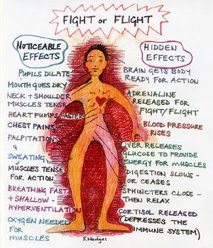 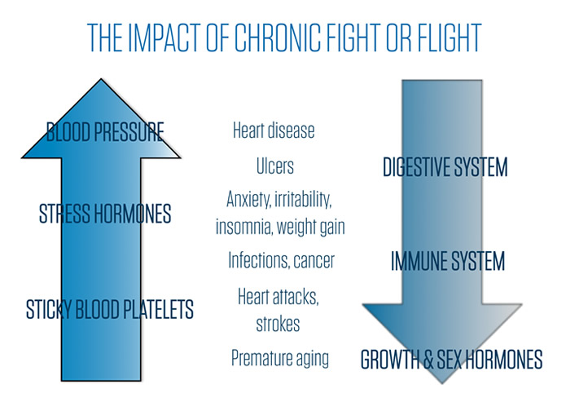
Batesy – F. Hodges Eblin Group
Article: https://www.verywellmind.com/ptsd-and-the-fight-or-flight-response-2797642
Site: http://www.thebodysoulconnection.com/EducationCenter/fight.html
- Freeze – What has cause the incapacity to try, to act…?
- Face – How can facing fears see the difference of humanizing and dehumanizing…?
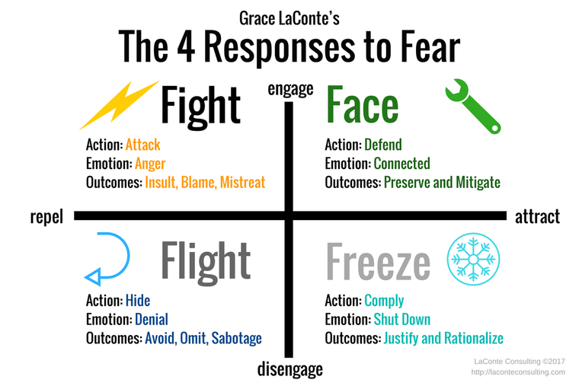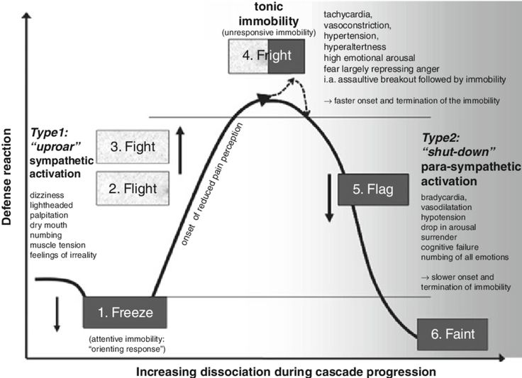
Site: https://laconteconsulting.com
Article: https://www.nytimes.com/2017/10/26/well/live/fear-anxiety-therapy.html
Article: https://www.ncbi.nlm.nih.gov/pmc/articles/PMC3181681/
Article: https://www.carnegiecouncil.org/publications/ethics_online/0090
- Facilitate – How can putting on different lens, obtaining different perspectives, create different outcomes…?
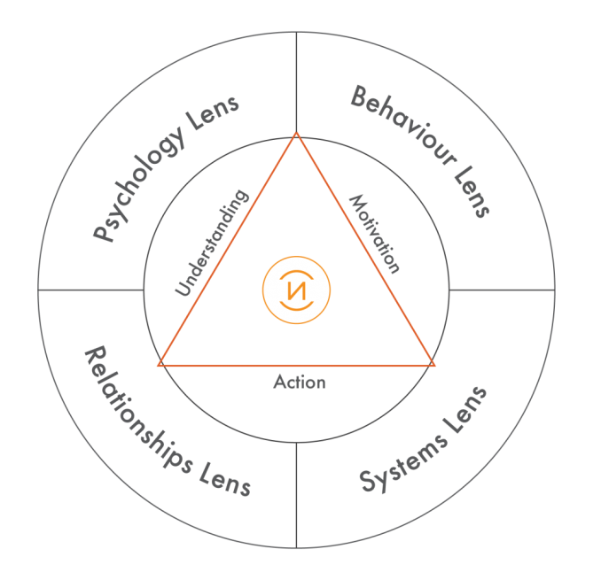 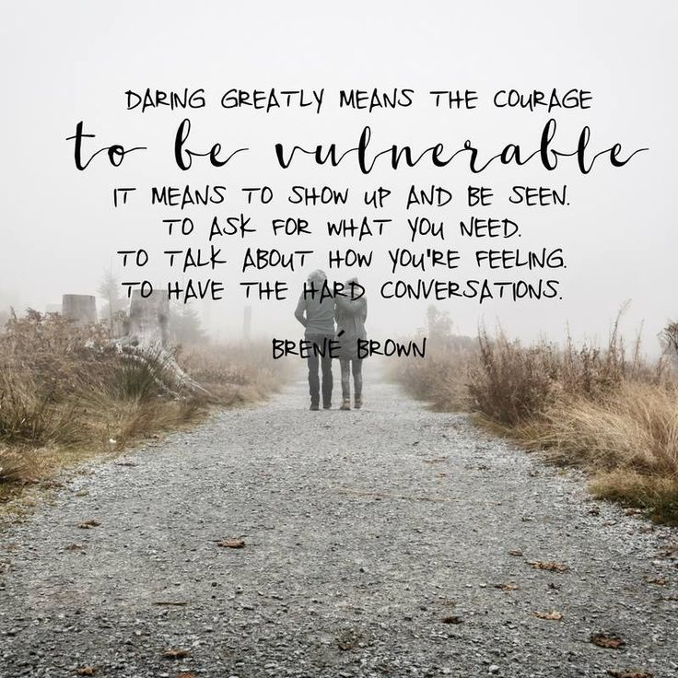
www.mindnavig8or.com
Article: http://www.mindnavig8or.com/resilience/ Article: http://www.leadershiplearning.org
Article: https://www.sciencedaily.com/releases/2014/08/140829084247.htm
Site: https://brenebrown.com/
- Freedom with Peace – Can I offer unconditional love, give forgiveness, be non-judgemental,…?
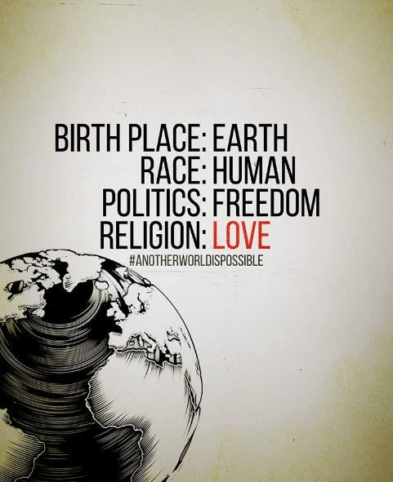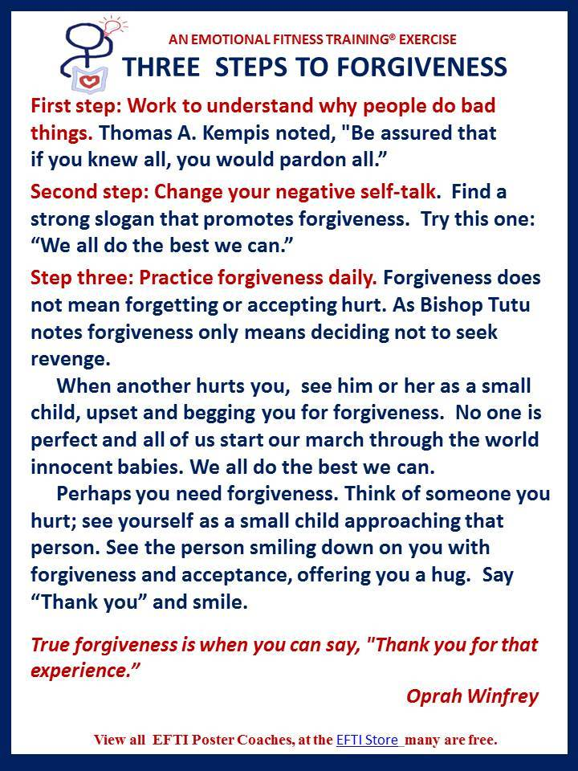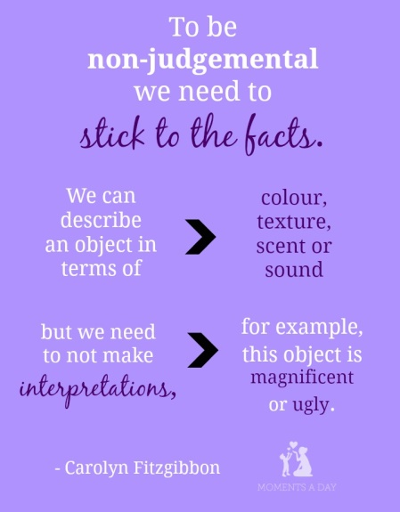
Quotes: https://www.psychologytoday.com/blog/here-there-and-everywhere/201101/36-quotes-peace-and-freedom
Article: http://www.theunapologeticlife.com/find-peace-challenging-relationships/
Article: https://www.huffingtonpost.com/randy-kamen-gredinger-edd/forgiveness_b_2006882.html
Site: https://www.wikihow.com/Not-Be-Judgemental
- Formulate – What can acts can I choose to improve my relationships, environment,…?
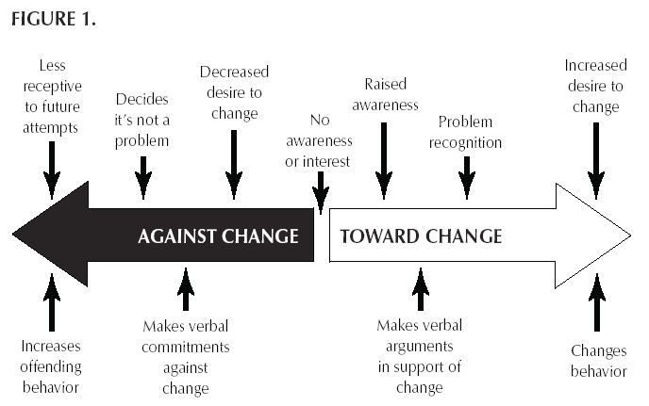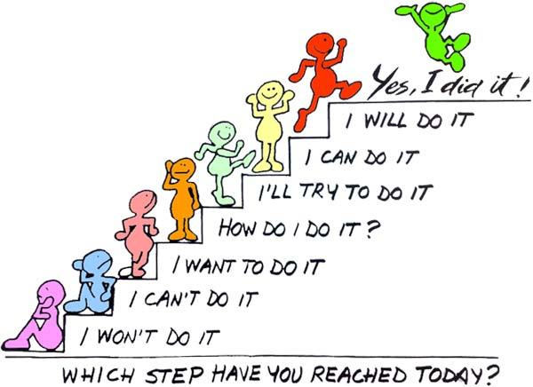
Article: http://time.com/3404749/10-ways-improve-your-relationship/
Site: https://www.instituteforwellness.com/
Search on YouTube:
Gottman
A to Z on Fight or Flight
Brene Brown
Kotter, not ‘Welcome Back…”
The Four Agreements – Don Miguel Ruiz
“We are no longer free because the Judge, the Victim, and the belief system don’t allow us to be who we really are. Once our minds have been programmed with all that garbage, we are no longer happy.”
“The chain of training from human to human, from generation to generation, is perfectly normal in society. You don’t need to blame your parents for teaching you to be like them. What else could they teach you but what they know?”
“There is no need to blame your parents or anyone who abused you in your life, including yourself. But it is time to stop the abuse…..free yourself of the tyranny of the Judge by changing the foundation of your own agreements. It is time to be free from the role of the Victim.”
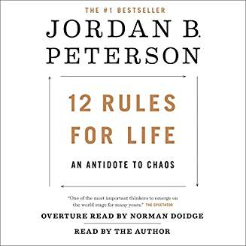
The 12 Rules for Life – Jordan Peterson - http://maestrocursos.com.br/the-13-truths-jordan-peterson/ and others on YouTube.
40 Profound Life Rules – Jordan Peterson - http://highexistence.com/jordan-peterson-rules-living/
“We need to give encouragement. A person needs so little encouragement.”
“You have to treat yourself as if you matter. If you don’t, you take it out on yourself…you become cruel, vengeful…and you take it out on others and everyone around you suffers.”
“Those who get their act together, even just a little bit, begin to heal and the spreads to those around them.”
Articles:
Coping Responses and Posttraumatic Stress Symptomatology in Urban Fire Service Personnel
by Randal Beaton, Shirley Murphy, Clark Johnson, Ken Pike and Wayne Cornell.
Relationships Among Traumatic Experiences, PTSD, and Posttraumatic Growth for Police Officers: A Path Analysis by Brian A. Chopko, Patrick A. Palmieri, and Richard E. Adams.
Trauma in the Eye of the Beholder: Objective and Subjective Definitions of Trama
by Adriel Boals

